**Software Requirements Specifications (SRS)**

**ERP Solution for Lakhsma Sweater Ltd.**

REFERENCE: GW/ERP/SRS/

**Version: 1.0**

**Date of Release: October 5, 2015**



**Genweb2 Limited**

TK Bhaban (11th Floor),

13 Kazi Nazrul Islam Avenue,

Kawran Bazar, Dhaka 1215, Bangladesh

web: [http://www.genweb2.com](http://www.genweb2.com/)

**Contents**

Document Release History 4

1.0 Introduction 5

1.1 Purpose of SRS 5

2.0 Procurement 6

2.1 Overview 6

2.2 Functional features of Merchandiser modules are given below (actor wise) 6

2.3 Procurement Process flow 7

2.4 User Class 7

3.0 Process Flow: 9

3.1 Raise purchase requisition 9

3.2 Receive Quotation: 10

3.3 Issue purchase order 11

4.0 CASE Diagram 13

4.1 Style process 13

4.2 Quotation Process: 13

4.3 Sample Process: 14

4.4 Export Order Process: 14

4.5 BOM Process: 15

5.0 USE CASE Details 16

5.1 UC/Pro/001/ Raise Purchase Requisition 16

5.2 UC/Pro/002/ Edit/Modify Purchase requisition 17

5.3 UC/Pro/003/ Raise Purchase requisition 18

5.4 UC/Pro/004/ Cancel Purchase requisition 19

5.5 UC/Pro/005/ Close Purchase requisition 20

5.6 UC/Pro/006/ Receive Quotation 21

5.7 UC/Pro/007/ Edit/Modify Quotation 22

5.8 UC/Pro/008/ Select Quotation 23

5.9 UC/Pro/009/ Cancel Quotation 24

5.10 UC/Pro/010/ Issue Purchase Order 25

5.11 UC/Pro/011/ Edit/Modify Purchase Order 26

5.12 UC/Pro/012/ Approve Purchase Order Level_1 27

5.13 UC/Pro/013/ Approve Purchase Order Level_2 28

5.14 UC/Pro/013/ Cancel Purchase order 29

6.0 Merchandising mock-up 30

6.1 Merchandising master user interface mock-up 30

6.1.1 Buyer’s Departments: 30

6.1.2 Currency 31

6.1.3 Season 31

6.1.4 Size Group 32

6.1.5 Unit of measurement 32

6.2 Merchandising Operational user interface mock-up 33

6.2.1 Style 33

6.2.2 Sample requisition and submission 34

6.2.3 Pre-costing mock-up 35

6.2.4 Buyer work order 36

6.2.5 Materials Consumption 37

6.2.6 Bill Of Material (BOM) 38

Document Release History

| Sl. No. | Version Number | Release Date | Prepared By | Reviewed By | Approved By | Reasons for New Release |
| --- | --- | --- | --- | --- | --- | --- |
| 1 | 1.0 | 5th Oct, 2015 | Nazifa Chowdhury |  | N/A |  |
|  |  |  |  |  |  |  |

# Introduction

## Purpose of SRS

The purposes of this SRS are to clearly identify the customer requirements and provide a detailed document. The customer will review the document and approve/make change as required. It will also help the review team to be able to validate whether the customer requirements has been fulfilled.

The SRS will also help the Analyst and Designer to understand and track the Requirements for the proposed system. It will also identify a set of requirements for the Development of the project. The SRS helps to describe the behavior of the system to be developed.

# Procurement

## Overview

Procurement is the act of acquiring, buying goods, services or works from an external source. It is favorable that the goods, services or works are appropriate and that they are procured at the best possible cost to meet the needs of the acquirer in terms of quality and quantity, time, and location.

## Functional features of Merchandiser modules are given below (actor wise)

* Employee/Department/Production floor raise indent
* Store keeper raise purchase requisition
* Approval authority check purchase requisition if they do not approve then purchase requisition will be cancel
* When approval authority approve purchase requisition then procurement executive send request to supplier(s) for quotation
* Procurement executive get quotation from several supplier
* Procurement executive request procurement manager select quotation
* If procurement manager do not select any quotation then quotation will be cancel
* If procurement manager select quotation then procurement executive cerate purchase order
* Procurement executive issue purchase order and send purchase order to procurement manager
* If procurement manager not approve purchase order then purchase order will be cancel
* If procurement manager approve the purchase order then he send request to management for approving purchase order
* Management receive request for approval purchase order from procurement manager
* If management do not approve then purchase order will be cancel
* If management approve purchase order then procurement manager get acknowledgement from management
* Procurement executive get acknowledgement from procurement manager
* Purchase order sent to supplier

## Procurement Process flow

* Raise purchase requisition
* Receive Quotation
* Issue purchase order

## User Class

| **User Class / Actor** | **Characteristics** | **Responsibilities** |
| --- | --- | --- |
|  |  |  |
|  |  |  |
|  |  |  |

# Process Flow:

## Raise purchase requisition

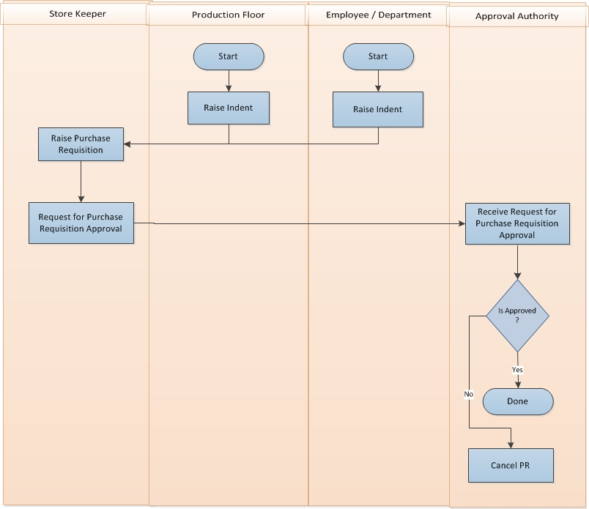

Fig: Raise purchase requisition

Raise purchase requisition details:

* Production Floor or Employee/Department raise Indent for specific item to Store Keeper.
* Store Keeper receives Purchase Requisition and takes necessary steps to process the request.
* After verifying Request for Purchase store keeper sends the request to Approval Authority for approval.
  + If requisition contains valid information, then Approval Authority approves the requisition.
  + Otherwise Approval Authority rejects the request.

## Receive Quotation:

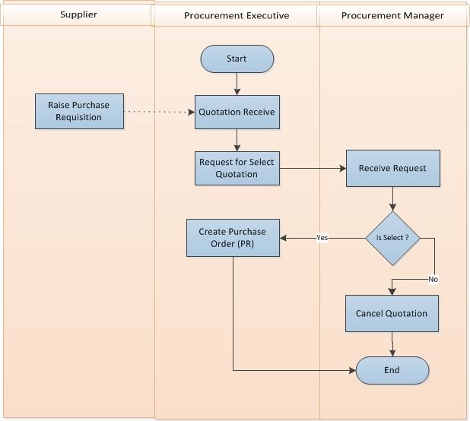

Fig: Receive Quotation

Receive Quotation details

* Procurement Executive receives Quotation which was send by supplier with details specification of materials/products.
* Procurement Executive request to Procurement Manager for Request for Select Quotation depending on receives purchased requisition.
* Procurement Manager receives the Request and takes necessary decision
  + If select: If Procurement Manager select the quotation, then sent a selection confirmation message for taking necessary steps
  + If rejected: If Procurement Manager rejects the quotation, then process will stop.
* After getting Selection confirmation message from Procurement Manager, Procurement Executive creates Purchase Order (PO).

## Issue purchase order

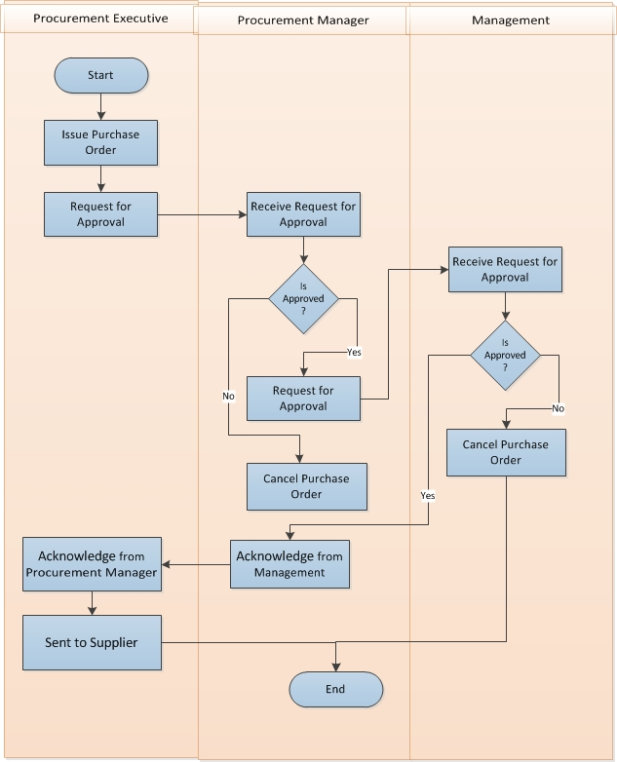

Fig: Issue purchase order

Issue purchase order details

* Procurement Executive issue purchase order
* Procurement Executive send request to Procurement Manager for Purchase Order Approval
* Procurement Manager receive Purchase Order from Procurement Executive
* If Procurement Manager is approve then sent request to Management for Purchase Order Approval
* If Procurement Manager is not approve then cancel the Purchase Order
* Management receive Purchase Order from Procurement Manager
* If Management is approve then back to Procurement Manager.
* Procurement Manager receives approval from Management and acknowledge to Procurement Executive.
* Procurement Executive send Approval Purchase Order to Supplier
* If Management is not approve then cancel the Purchase Order

# CASE Diagram

## Style process

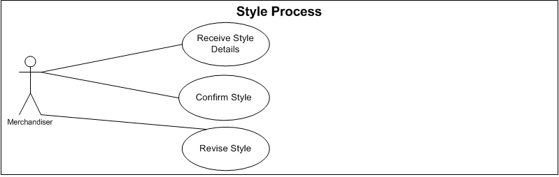

Fig: Style process use case

## Quotation Process:

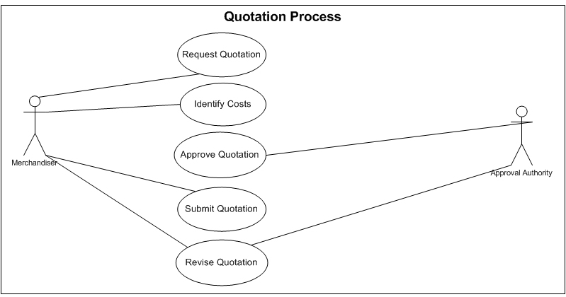

Fig: Quotation process use case

## Sample Process:

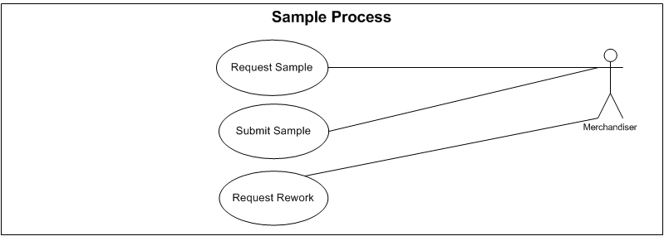

Fig: Sample process use case

## Export Order Process:

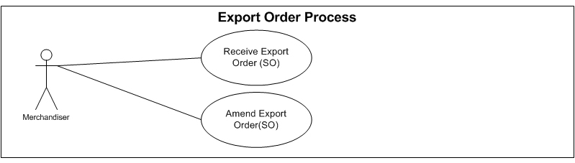

Fig: Export Order Process use case

## BOM Process:

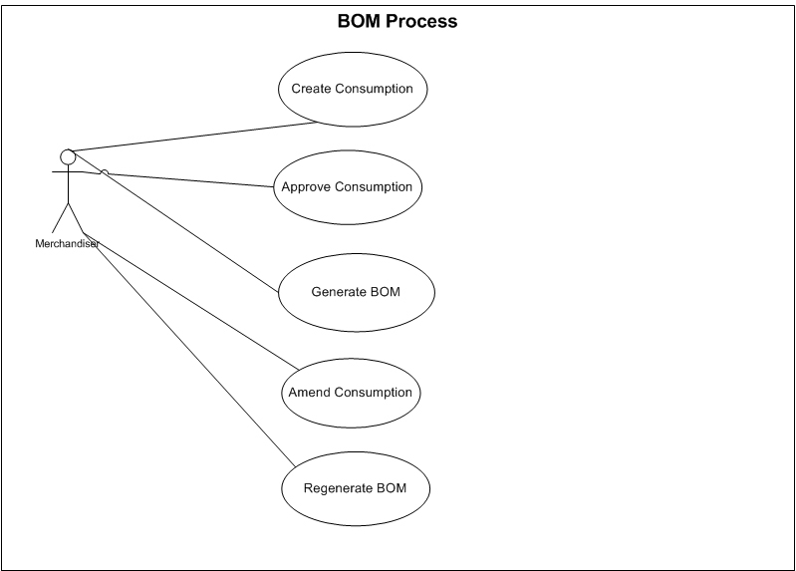

Fig: Bill Of Materials use case

# USE CASE Details

## UC/Pro/001/ Raise Purchase Requisition

|  |  |  |
| --- | --- | --- |
| Use Case ID: UC/Pro/001 | | |
| Use Case Name**: Raise Purchase Requisition** | | |
| Created By: **GenWeb2 Ltd.** | | Date Created: 30 September, 2015 |
| Actors: | * Store Authority | |
| Trigger: | * When Store Authority needs to raise Purchase Requisition | |
| Description: | If inventory needs to purchase any item against any indent (from production floor or employee) or independently then Inventory Authority raise a purchase Requisition to Procurement Department to Source those items | |
| Frequency of Use | * Medium | |
| Preconditions | * N/A | |
| Post conditions | * N/A | |
| Assumption | * N/A | |
| Goal | Create Purchase Requisition in System | |
| Normal Flow | 1. Inventory receive item Indent 2. If stock not available of that item then Inventory raise Purchase Requisition | |
| Alternate Flow | 1. Inventory Authority can raise Purchase Requisition if any item stock is under reorder level | |
| Exception | * N/A | |
| Cross Reference | * N/A | |

## UC/Pro/002/ Edit/Modify Purchase requisition

|  |  |  |
| --- | --- | --- |
| Use Case ID: UC/Pro/002 | | |
| Use Case Name**: Edit/Modify Purchase requisition** | | |
| Created By: **GenWeb2 Ltd.** | | Date Created: 30 September, 2015 |
| Actors: | * Store Authority | |
| Trigger: | * When any modification requires for any unapproved Purchase Requisition | |
| Description: | If changes or modification requires for any raised and unapproved Purchase requisition then store authority edit/Modify that Purchase Requisition | |
| Frequency of Use | * Medium | |
| Preconditions | * Purchase Requisition | |
| Post conditions | * Can’t be Approved | |
| Assumption | * N/A | |
| Goal | Edit/Modify Purchase Requisition | |
| Normal Flow | 1. Any mistake/Changes in any raised Purchase Requisition 2. Store Authority Edit/Modify the Purchase Requisition | |
| Alternate Flow | * N/A | |
| Exception | * N/A | |
| Cross Reference | * UC/Pro/001 | |

## UC/Pro/003/ Raise Purchase requisition

|  |  |  |
| --- | --- | --- |
| Use Case ID: UC/Pro/003 | | |
| Use Case Name**: Raise Purchase requisition** | | |
| Created By: **GenWeb2 Ltd.** | | Date Created: 30 September, 2015 |
| Actors: | * Store Manager | |
| Trigger: | * When any raised Purchase Requisition needs approval for further action | |
| Description: | After raising Purchase Requisition by the store authority it needs to be approved by the Store manager for further approval | |
| Frequency of Use | * Medium | |
| Preconditions | * Raise Purchase Requisition | |
| Post conditions | * N/A | |
| Assumption | * N/A | |
| Goal | Approve Purchase Requisition for further use | |
| Normal Flow | 1. Store Authority raise Purchase Requisition 2. Store Manager Approve the Purchase Requisition | |
| Alternate Flow | 1. Store Authority raise Purchase Requisition 2. Defined approval authority other than Store Manager can approve the Purchase Requisition 3. 2nd layer approval may take palace | |
| Exception | * N/A | |
| Cross Reference | * ID: UC/Pro/001 | |

## UC/Pro/004/ Cancel Purchase requisition

|  |  |  |
| --- | --- | --- |
| Use Case ID: UC/Pro/004 | | |
| Use Case Name**: Cancel Purchase requisition** | | |
| Created By: **GenWeb2 Ltd.** | | Date Created: 30 September, 2015 |
| Actors: | * Store Manager or Authorized Store Authority | |
| Trigger: | * When any Purchase Requisition get cancelled by the authority(Approved & Unapproved both) | |
| Description: | If any Purchase Requisition get Invalid then the authority cancel that Purchase Requisition | |
| Frequency of Use | * Low | |
| Preconditions | * Raise Purchase Requisition | |
| Post conditions | * N/A | |
| Assumption | * N/A | |
| Goal | Cancel any Purchase Requisition | |
| Normal Flow | 1. Store Authority raise Purchase Requisition 2. Store Manager Approve the Purchase Requisition 3. Store Authority Cancel the Purchase Requisition(Approved & unapproved both) | |
| Alternate Flow | * N/A | |
| Exception | * N/A | |
| Cross Reference | * ID: UC/Pro/001 | |

## UC/Pro/005/ Close Purchase requisition

|  |  |  |
| --- | --- | --- |
| Use Case ID: UC/Pro/005 | | |
| Use Case Name**: Close Purchase requisition** | | |
| Created By: **GenWeb2 Ltd.** | | Date Created: 30 September, 2015 |
| Actors: | * Store Manager or Authorized Store Authority | |
| Trigger: | * When Store Authority wants to close any Purchase requisition | |
| Description: | If any Purchase Requisition have some pending Quantity to issue Purchase Order but decision has taken that it will not be executed anymore in that case the Purchase Requisition will be cancelled so that it will not display the pending item requisition quantity for Purchase order anymore. | |
| Frequency of Use | * Low | |
| Preconditions | * Raise Partial Purchase Order | |
| Post conditions | * Existing Purchase Order will remain same and will be workable * New Purchase Order can’t be created against that Purchase Requisition | |
| Assumption | * N/A | |
| Goal | Close any Purchase Requisition | |
| Normal Flow | 1. Store Authority raise Purchase Requisition 2. Store Manager Approve the Purchase Requisition 3. Procurement Authority Issue Purchase Order (Partial) 4. Store Authority | |
| Alternate Flow | * N/A | |
| Exception | * N/A | |
| Cross Reference | * ID: UC/Pro/001 | |

## UC/Pro/006/ Receive Quotation

|  |  |  |
| --- | --- | --- |
| Use Case ID: UC/Pro/006 | | |
| Use Case Name**: Receive Quotation** | | |
| Created By: **GenWeb2 Ltd.** | | Date Created: 30 September, 2015 |
| Actors: | * Procurement Authority | |
| Trigger: | * When Store Authority receives any quotation from Supplier | |
| Description: | Purchase Authority ask price quotation from various supplier, Suppliers send price quotation of those asking products, Purchase Authority receive enter those price quotation to system for further selection | |
| Frequency of Use | * Medium | |
| Preconditions | * N/A | |
| Post conditions | * Selection of Quotation | |
| Assumption | * N/A | |
| Goal | Enter Price Quotations from Supplier in System for further use | |
| Normal Flow | 1. Purchase Authority Receive price Quotation from Suppliers | |
| Alternate Flow | * N/A | |
| Exception | * N/A | |
| Cross Reference | * N/A | |

## UC/Pro/007/ Edit/Modify Quotation

|  |  |  |
| --- | --- | --- |
| Use Case ID: UC/Pro/007 | | |
| Use Case Name**: Edit/Modify Quotation** | | |
| Created By: **GenWeb2 Ltd.** | | Date Created: 30 September, 2015 |
| Actors: | * Procurement Authority | |
| Trigger: | * When Supplier revise any price quotation | |
| Description: | If Supplier revise the price Quotation. | |
| Frequency of Use | * Medium | |
| Preconditions | * Receive Quotation | |
| Post conditions | * N/A | |
| Assumption | * N/A | |
| Goal | Update the Price Quotation in System | |
| Normal Flow | 1. Purchase Authority Receive price Quotation from Suppliers 2. Supplier revised the quotation and Purchase Authority address accordingly | |
| Alternate Flow | * N/A | |
| Exception | * N/A | |
| Cross Reference | * UC/Pro/006 | |

## UC/Pro/008/ Select Quotation

|  |  |  |
| --- | --- | --- |
| Use Case ID: UC/Pro/008 | | |
| Use Case Name**: Select Quotation** | | |
| Created By: **GenWeb2 Ltd.** | | Date Created: 30 September, 2015 |
| Actors: | * Procurement Manager | |
| Trigger: | * When Purchase manager select/finalize any Quotation | |
| Description: | When Purchase manager select/finalize any Quotation from Supplier for issuing Purchase Order against that quotation | |
| Frequency of Use | * Medium | |
| Preconditions | * Receive Quotation | |
| Post conditions | * Issue Purchase Order | |
| Assumption | * N/A | |
| Goal | Issue Purchase Order to Supplier in System | |
| Normal Flow | 1. Purchase Authority Receive price Quotation from Suppliers 2. Purchase Manager Select Quotation for issuing purchase Order | |
| Alternate Flow | * N/A | |
| Exception | * N/A | |
| Cross Reference | * UC/Pro/006 | |

## UC/Pro/009/ Cancel Quotation

|  |  |  |
| --- | --- | --- |
| Use Case ID: UC/Pro/009 | | |
| Use Case Name**: Cancel Quotation** | | |
| Created By: **GenWeb2 Ltd.** | | Date Created: 30 September, 2015 |
| Actors: | * Procurement Manager or Nominated Procurement Authority | |
| Trigger: | * When authorized Procurement authority wants to Cancel any Quotation | |
| Description: | If any Quotation get Invalid for any further usages then the authorized person cancel that Quotation to prevent any further use of that Quotation | |
| Frequency of Use | * Medium | |
| Preconditions | * Receive Quotation | |
| Post conditions | * N/A | |
| Assumption | * N/A | |
| Goal | Cancel any Quotation for prevent any further usages | |
| Normal Flow | 1. Purchase Authority Receive price Quotation from Suppliers 2. Price Quotation got invalid and Authorized Procurement people cancel that Quotation | |
| Alternate Flow | * N/A | |
| Exception | * N/A | |
| Cross Reference | * UC/Pro/006 | |

## UC/Pro/010/ Issue Purchase Order

|  |  |  |
| --- | --- | --- |
| Use Case ID: UC/Pro/010 | | |
| Use Case Name**: Issue Purchase Order** | | |
| Created By: **GenWeb2 Ltd.** | | Date Created: 30 September, 2015 |
| Actors: | * Procurement Authority | |
| Trigger: | * When Procurement authority wants to issue any Purchase Order | |
| Description: | If Procurement Authority wants to issue any Purchase Order against any Purchase Requisition or Bill Of Materials or even Independently(with Concern of the authority) | |
| Frequency of Use | * Medium | |
| Preconditions | * Purchase requisition * Bill of Materials | |
| Post conditions | * N/A | |
| Assumption | * N/A | |
| Goal | Issue Purchase Order in System | |
| Normal Flow | 1. Purchase Requisition raise by Inventory and get approved 2. Bill of Materials generated by Merchandiser for any order and got approved. 3. Purchase Authority issue Purchase order against Purchase Requisition or Bill of Materials | |
| Alternate Flow | * Can be issued independently for special case | |
| Exception | * N/A | |
| Cross Reference | * N/A | |

## UC/Pro/011/ Edit/Modify Purchase Order

|  |  |  |
| --- | --- | --- |
| Use Case ID: UC/Pro/011 | | |
| Use Case Name**: Edit/Modify Purchase Order** | | |
| Created By: **GenWeb2 Ltd.** | | Date Created: 30 September, 2015 |
| Actors: | * Procurement Authority | |
| Trigger: | * When Procurement authority needs to edit/Modify any Purchase Order before Approval | |
| Description: | If there is any mistake to correct or update needs to incorporate in Purchase Order then Procurement authority can Edit/Modify that Purchase Order only if it is not approved yet. | |
| Frequency of Use | * Medium | |
| Preconditions | * Purchase Order | |
| Post conditions | * N/A | |
| Assumption | * N/A | |
| Goal | Update/Correct Purchase Order in System | |
| Normal Flow | 1. Purchase Order get issue by the procurement authority 2. Procurement Authority edit/Modify the Purchase Order if Require | |
| Alternate Flow | * N/A | |
| Exception | * N/A | |
| Cross Reference | * N/A | |

## UC/Pro/012/ Approve Purchase Order Level_1

|  |  |  |
| --- | --- | --- |
| Use Case ID: UC/Pro/012 | | |
| Use Case Name**: Approve Purchase Order Level_1** | | |
| Created By: **GenWeb2 Ltd.** | | Date Created: 30 September, 2015 |
| Actors: | * Procurement Manager | |
| Trigger: | * When Procurement Manager wants to approve any Purchase Order | |
| Description: | After issuing any Purchase Order Purchase manager needs to approve Purchase Order for Level_1 approval | |
| Frequency of Use | * Medium | |
| Preconditions | * Purchase Order | |
| Post conditions | * Approve Purchase Order Level_2 | |
| Assumption | * N/A | |
| Goal | Level_1 approval for the Purchase Order | |
| Normal Flow | 1. Purchase Order get issue by the procurement authority 2. Purchase Manager approve the level_1 approval of the Purchase Order | |
| Alternate Flow | * N/A | |
| Exception | * N/A | |
| Cross Reference | * Use Case ID: UC/Pro/011 | |

## UC/Pro/013/ Approve Purchase Order Level_2

|  |  |  |
| --- | --- | --- |
| Use Case ID: UC/Pro/013 | | |
| Use Case Name**: Approve Purchase Order Level_2** | | |
| Created By: **GenWeb2 Ltd.** | | Date Created: 30 September, 2015 |
| Actors: | * Management | |
| Trigger: | * When Management wants to approve any Purchase Order | |
| Description: | After issuing any Purchase Order Purchase manager needs to approve Purchase Order for Level_1 approval and then Level_2 approval needs from the Management | |
| Frequency of Use | * Medium | |
| Preconditions | * Purchase Order | |
| Post conditions | * N/A | |
| Assumption | * N/A | |
| Goal | Level_2 approval for the Purchase Order | |
| Normal Flow | 1. Purchase Order get issue by the procurement authority 2. Purchase Manager approve the level_1 approval of the Purchase Order 3. Management approve the Level_2 approval of the Purchase Order | |
| Alternate Flow | 1. Purchase Order get issue by the procurement authority 2. Management approve the Level_2 approval of the Purchase Order 3. Level_1 approval will not require in that case | |
| Exception | * N/A | |
| Cross Reference | * Use Case ID: UC/Pro/011 | |

## UC/Pro/013/ Cancel Purchase order

|  |  |  |
| --- | --- | --- |
| Use Case ID: UC/Pro/013 | | |
| Use Case Name**: Cancel Purchase order** | | |
| Created By: **GenWeb2 Ltd.** | | Date Created: 30 September, 2015 |
| Actors: | * Purchase manager or Authorized Purchase authority | |
| Trigger: | * When Purchase Manager or Purchase authority wants to cancel any Purchase Order | |
| Description: | Approved and unapproved Purchase Order can get cancelled for any reason. In that case the authority cancel the Purchase order so it will not flow for further use | |
| Frequency of Use | * Medium | |
| Preconditions | * Purchase Order | |
| Post conditions | * N/A | |
| Assumption | * N/A | |
| Goal | Cancel any Purchase order to restrict it for any further flow | |
| Normal Flow | 1. Purchase Order get issue by the procurement authority 2. Procurement Authority cancel the Purchase Order | |
| Alternate Flow | 1. Purchase Order get issue by the procurement authority 2. Purchase Manager approve the level_1 approval of the Purchase Order 3. Management approve the Level_2 approval of the Purchase Order 4. Procurement Authority cancel the Purchase Order (After approval) | |
| Exception | * N/A | |
| Cross Reference | * Use Case ID: UC/Pro/011 | |

# Merchandising mock-up

## Merchandising master user interface mock-up

### Buyer’s Departments:

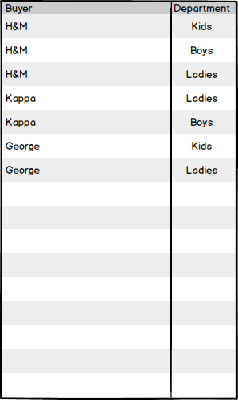

Fig: Buyer’s Department

### Currency

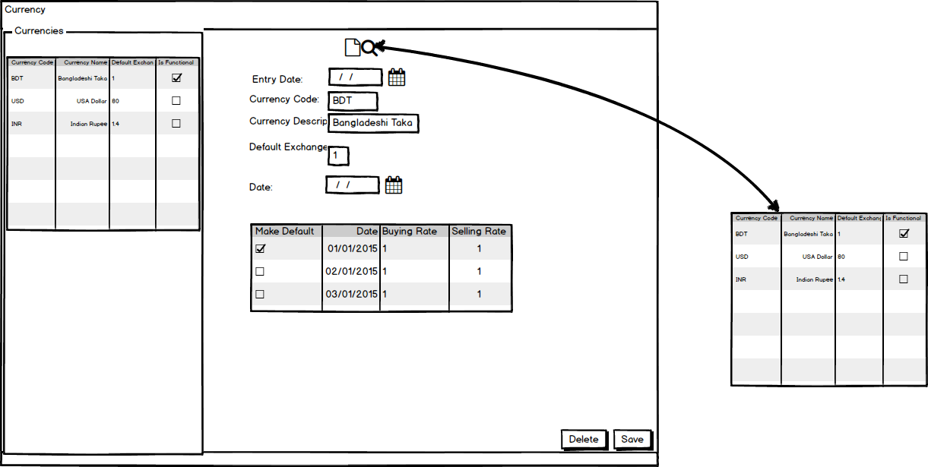

Fig: Currency

### Season

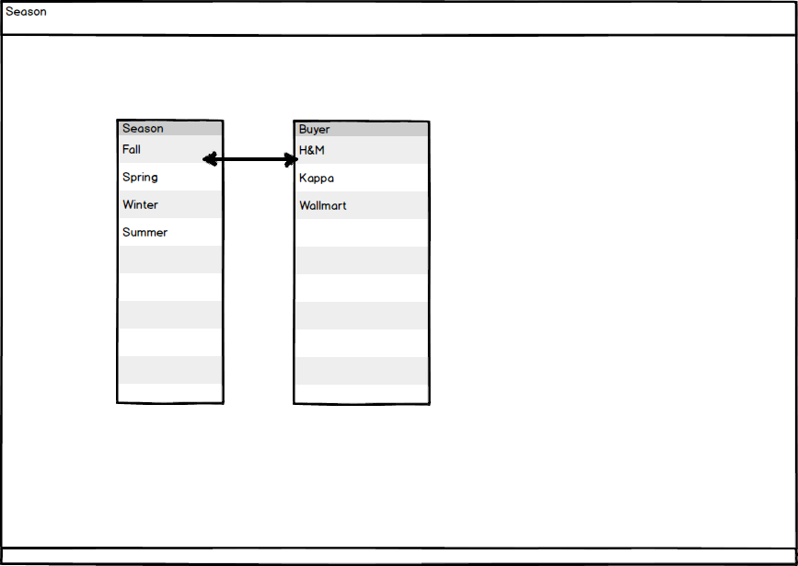

Fig: Season

### Size Group

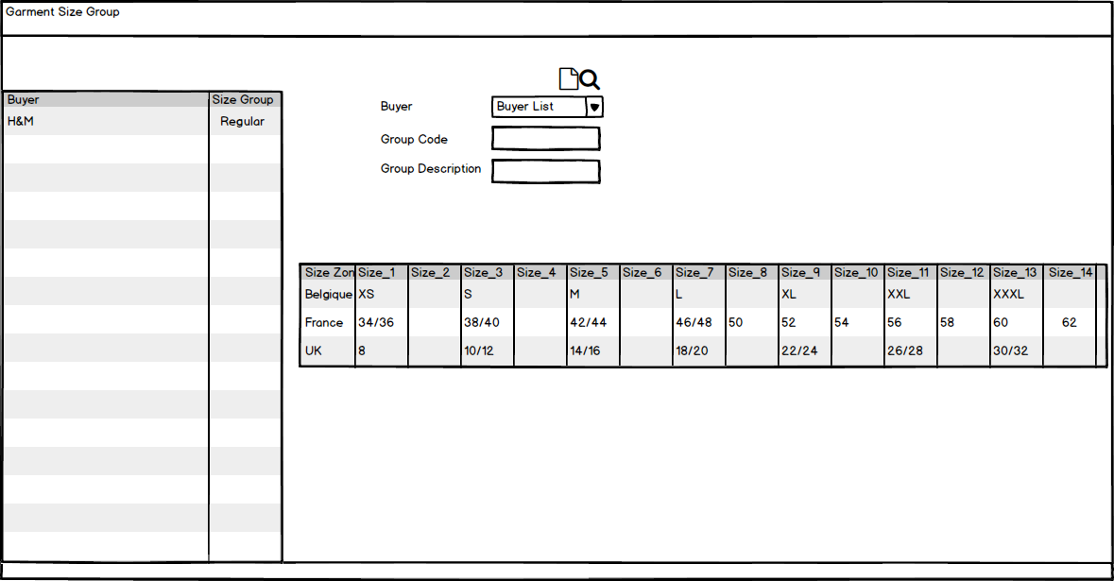

Fig: Size group

### Unit of measurement

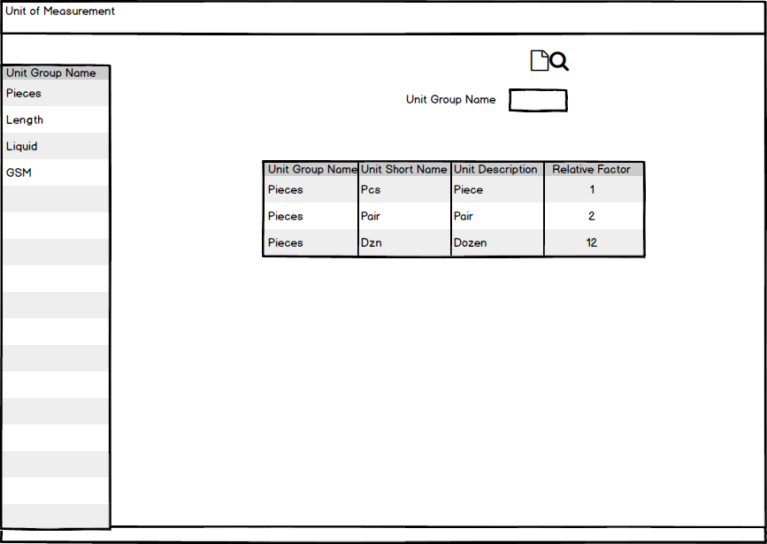

Fig: Unit of measurement

## Merchandising Operational user interface mock-up

### Style

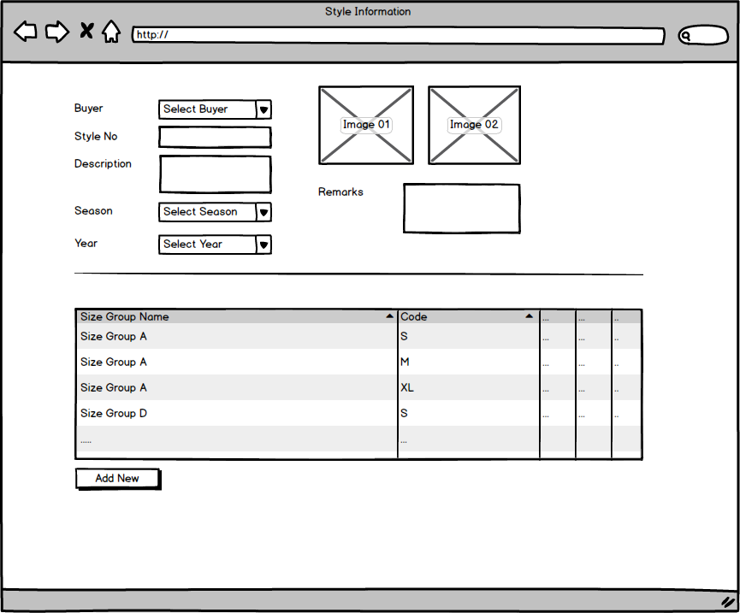

Fig: Style

### Sample requisition and submission

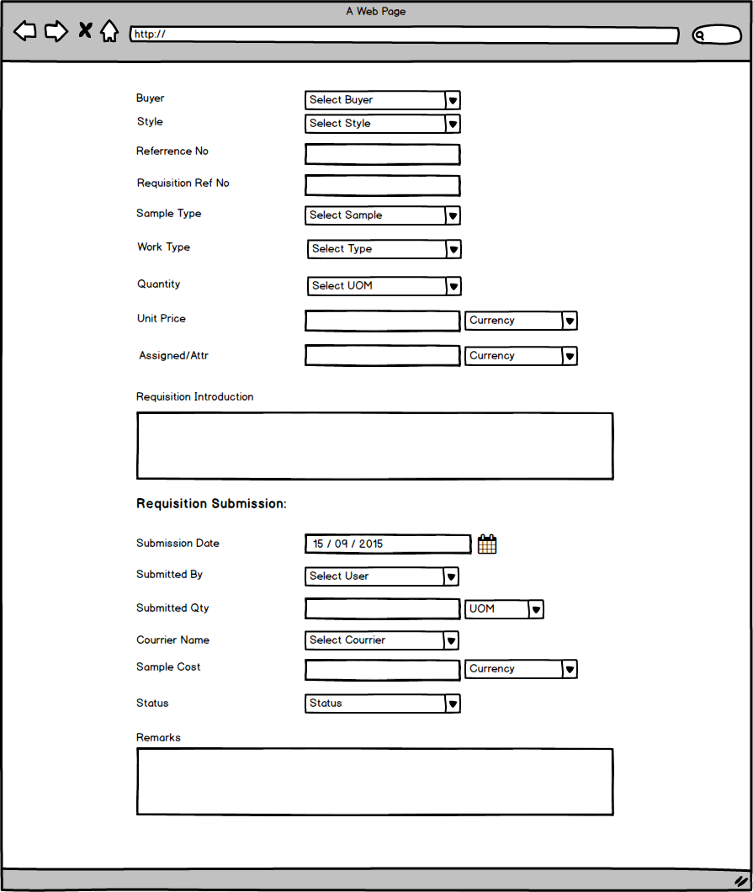

Fig: Sample requisition and submission

### Pre-costing mock-up

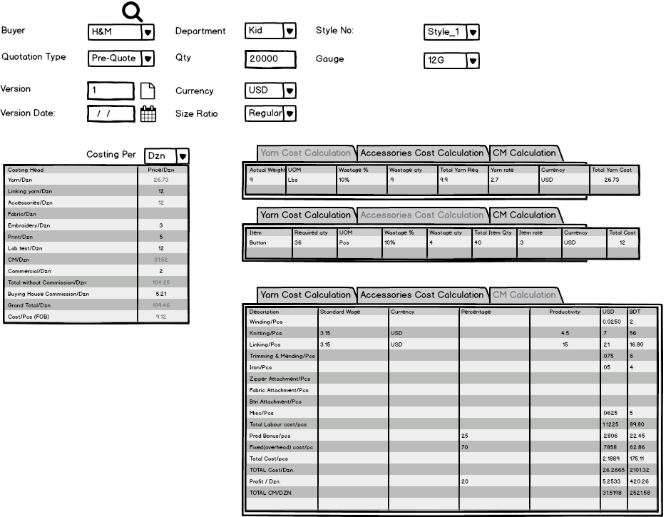

Fig: Pre-costing mock-up

### Buyer work order

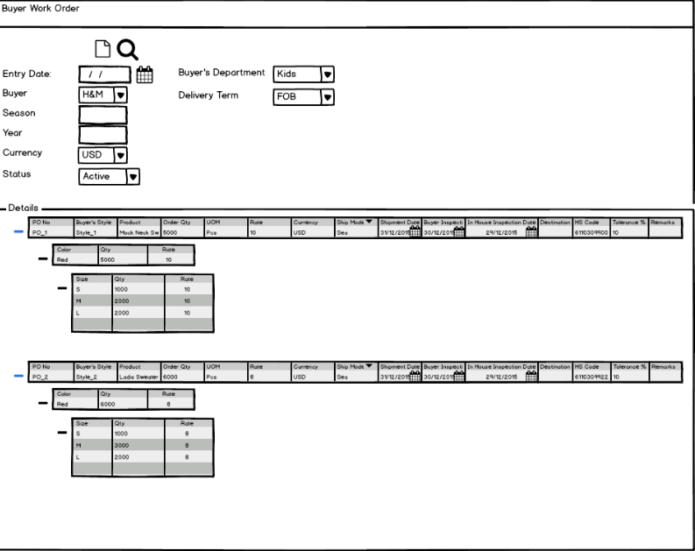

Fig: Buyer work order

### Materials Consumption

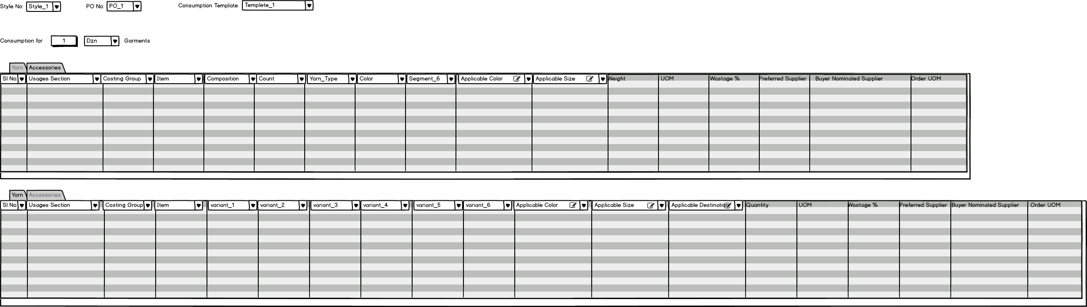

Fig: Material Consumption

### Bill Of Material (BOM)

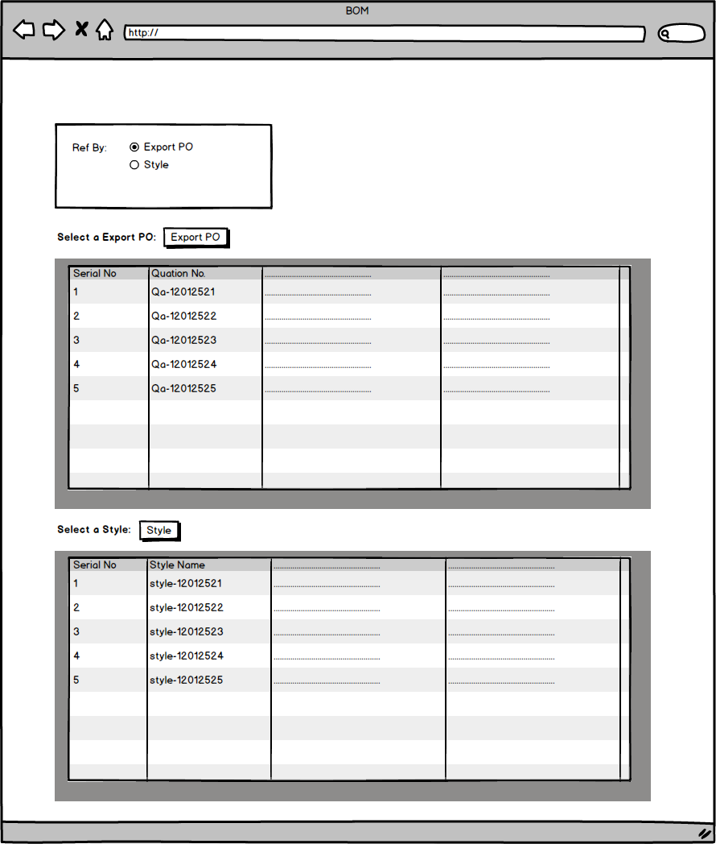

Fig: Bill Of Material (BOM)